Scientific Method - Group Project
Instructions: Read the scenario below and design a controlled experiment to answer the scientific question. You must use the steps of the scientific method and identify the control group, dependent variable, independent variable, state your hypothesis and the possible outcomes. You will also need to identify what type of data will be collected. You will not be performing this experiment only designing an experiment that could test the answer to the question.
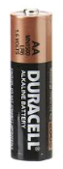
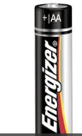
You have been put in charge of providing flashlights for emergency use in each of the classrooms of the school. You have been given an account with limited funds to purchase the flashlights and batteries. With your limited funds you want to purchase the batteries that last the longest. Which battery lasts longer, Energizer or Duracell?

