Scientific Method - Group Project
Instructions: Read the scenario below and design a controlled experiment to answer the scientific question. You must use the steps of the scientific method and identify the control group, dependent variable, independent variable, state your hypothesis and the possible outcomes. You will also need to identify what type of data will be collected. You will not be performing this experiment only designing an experiment that could test the answer to the question.
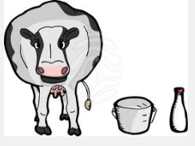
The link between cancer and dietary hormones - estrogen in particular - has been a source of great concern among scientists, but it has not been widely studied or discussed.
Dairy cattle are often milked late into pregnancy. During the late stages of pregnancy the estrogen levels increase significantly. The reasoning is that milk production increases with the increase of estrogen. There is debate concerning this practice. Does the hormone estrogen increase the milk yield of dairy cows?

