Name______________________________ Date________________

DNA Extraction: Strawberry

**Background:** The long, thick fibers of DNA store the information for the functioning of the chemistry of life. DNA is present in every cell of plants and animals. The DNA found in strawberry cells can be extracted using common, everyday materials. We will use an extraction buffer containing salt, to break up protein chains that bind around the nucleic acids, and dish soap to dissolve the lipid (fat) part of the strawberry cell wall and nuclear membrane. This extraction buffer will help provide us access to the DNA inside the cells.

Pre-lab questions:

1. Predict what the DNA will look like.

Use the rubric and assess your prediction:

|  |  |
| --- | --- |
| Self-Assess your prediction : | Teacher Assess your prediction: |

2. Where is DNA found?

3. **Infer** would this investigation work with other cells, such as cells from bananas, onions, or the cells from your own cheek? Why or why not?

**Materials:**

heavy duty ziploc bag

1 strawberry

10 mL DNA extraction buffer (soapy, salty water)

Cheesecloth/filter paper

funnel

50mL vial / test tube

glass rod, inoculating loop, or popsicle stick

20 mL ethanol

**Procedure:**

1. Place one strawberry in a Ziploc bag.

2. Smash/grind up the strawberry using your fist and fingers for 2 minutes. Careful not to break the bag!!

3. Add the provided 10mL of extraction buffer (salt and soap solution) to the bag.

4. Kneed/mush the strawberry in the bag again for 1 minute.

5. Assemble your filtration apparatus as shown to the below.

6. Pour the strawberry slurry into the filtration apparatus and let it drip directly into your test tube.

7. Slowly pour cold ethanol into the tube. OBSERVE

8. Dip the loop or glass rod into the tube where the strawberry extract and ethanol layers come into contact with each other.

**Filtration Apparatus:**

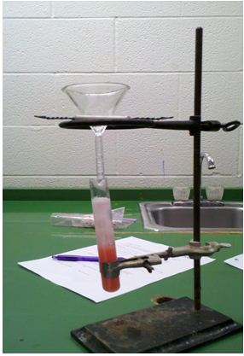



**OBSERVE**

What did the DNA look like (color, size, smell, feel)?

Post-Lab

Match the procedure with its function:

PROCEDURE FUNCTION

A. Filter strawberry slurry through cheesecloth ___ To precipitate DNA from solution

B. Mush strawberry with salty/soapy solution ___ Separate components of the cell

C. Initial smashing and grinding of strawberry ___ Break open the cells

D. Addition of ethanol to filtered extract ___ Break up proteins and dissolve cell

Membranes

2. What did the DNA look like? Relate what you know about the chemical structure of DNA to

what you observed today.

3. Explain what happened in the final step when you added ethanol to your strawberry extract.

(Hint: DNA is soluble in water, but not in ethanol)

4. A person cannot see single cotton thread 100 feet away, but if you wound thousands of threads together into a rope, it would be visible much further away. Is this statement analogous to our DNA extraction? Explain.

5. Why is it important for scientists to be able to remove DNA from an organism? List two reasons.