Scientific Method - Group Project
Instructions: Read the scenario below and design a controlled experiment to answer the scientific question. You must use the steps of the scientific method and identify the control group, dependent variable, independent variable, state your hypothesis and the possible outcomes. You will also need to identify what type of data will be collected. You will not be performing this experiment only designing an experiment that could test the answer to the question.

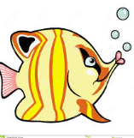
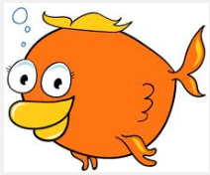
You are interested in purchasing a fish tank and fish for your new apartment. You realize there are many different sizes of tanks and a large variety of fishes to choose from. You like larger fish as they are easier to see from across the room. Before making a purchase you wonder if the size of a fish tank determine how large a fish will grow.

